INDEX
S.No. | Program Name | Signature
1 | Write a program to Draw line through DDA Line.
2 | Write a program to Draw line through Bheresham Line.
3 | Write a program to glow the Pixel on screen.
4 | Write a program to Draw a Rectangle.
5 | Write a program to Draw a Square.
6 | Write a program to Draw a Triangle.
7 | Write a program to Draw a Circle Bheresham.
8 | Write a program to Draw a line through Mid-Point Line Algorithm.
9 | Write a program to Draw a 2D Translation.
10 | Write a program to Draw a 2D Scaling.
11 | Write a program to Draw a Indian Flag on screen.
12 | Write a program to Make a Hut.
13 | Write a program to Draw a Kite.
14 | Write a program to Draw a Fish.
15 | Write a program to Change Background Colour Through pre-defined Function.
16 | Write a program to Filling Style Change Function.
 | Write a program to Draw a Circle Mid point

/*Write a program to Draw line through DDA Line*\
#include<stdio.h>
#include<conio.h>
#include<graphics.h>
#include<stdlib.h>
#include<dos.h>
#include<math.h>
void main()
{
int x,y,x1,x2,y1,y2,k,length,dx,dy;
int gdriver=DETECT,gmode,errorcode;
initgraph(&gdriver,&gmode,"..\\bgi");
printf("Enter the valueof x1 and y1:");
scanf("%d%d",&x1,&y1);
printf("Enter the value of x2 and y2:");
scanf("%d%d",&x2,&y2);
x=x2-x1;
y=y2-y1;
if(abs(x2-x1)>abs(y2-y1))
length=abs(x1-x2);
else
length=abs(y2-y1);
dx=(x2-x1)/length;
dy=(y2-y1)/length;
x=x1;
y=y1;
putpixel(x,y,BLUE);
for(k=0;k<=length;k++)
{
x=x+dx;
y=y+dy;
putpixel(x,y,RED);
delay(100);
}

getch();
closegraph();
}

OUTPUT:

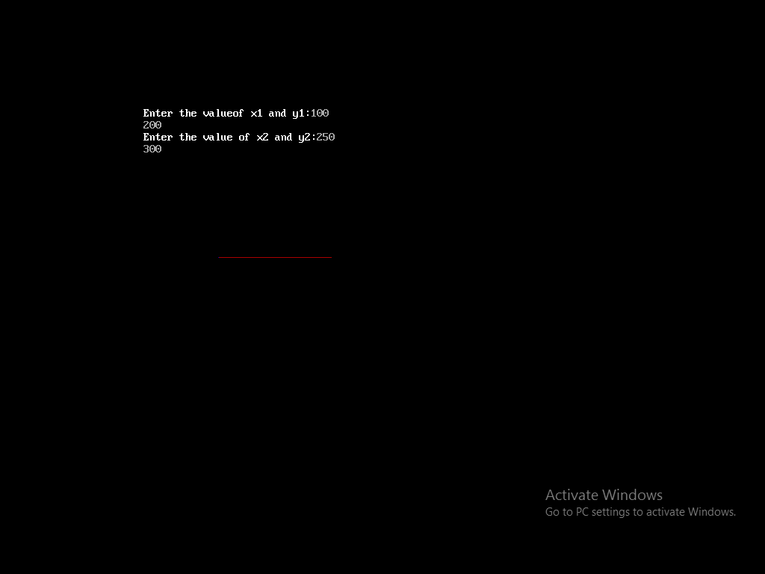

/*Write a program to Draw line through Bheresham Line*\

#include<stdio.h>
#include<conio.h>
#include<graphics.h>
#include<stdlib.h>
#include<dos.h>
#include<math.h>
void main()
{
int x,y,x1,x2,y1,y2,k,s1,s2,dp,dx,dy;
int gdriver=DETECT,gmode,errorcode;
initgraph(&gdriver,&gmode,"..\\bgi");
printf("Enter the valueof x1 and y1:");
scanf("%d%d",&x1,&y1);
printf("Enter the value of x2 and y2:");
scanf("%d%d",&x2,&y2);
putpixel(x1,y1,RED);
dx=x2-x1;
dy=y2-y1;
x=x1;
y=y1;
dx=2*dy-dx;
if(dx>0)
s1=1;
else
s1=-1;
if(dy>0)
s2=1;
else
s2=-1;
for(k=0;k<dx;k++)
{
if(dp<0)
{
x=x+s1;
y=y;

dp=dp+2*dy;
}
else
{
x=x+s1;
y=y+s2;
dp=dp-2*dx+2*dy;
}
putpixel(x,y,RED);
delay(100);
}
getch();
closegraph();
}

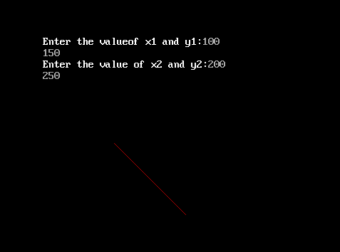
OUTPUT:-

/* Write a program to glow the Pixel on screen*\
#include<iostream.h>
#include<conio.h>
#include<graphics.h>
#include<stdlib.h>
int x,y;
void main()
{
int gdriver=DETECT,gmode,errorcode;
initgraph(&gdriver,&gmode,"..\\bgi");
cout<<"Enter the value of x:";
cin>>x;
cout<<"Enter the value of y:";
cin>>y;
putpixel(x,y,BLUE);
getch();
closegraph();
}

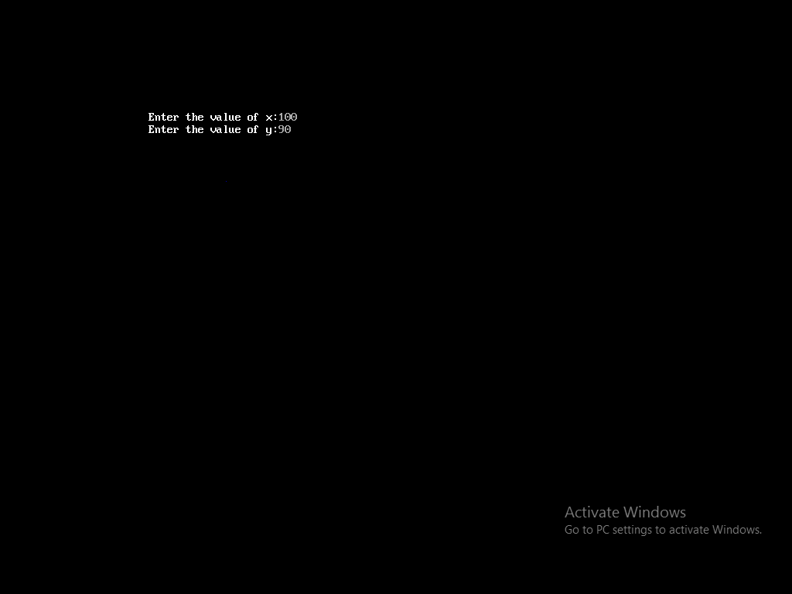
Output:-

/*Write a program to Draw a Rectangle*\

#include<graphics.h>
#include<conio.h>
#include<stdio.h>
int line1(int x1,int y1,int x2,int y2);
void main()
{
int x1,x2,y1,y2,length,dx,dy,x,y,k;
int gdriver=DETECT,gmode,errorcode;
initgraph(&gdriver,&gmode,"..\\bgi");
printf("Enter the value of x1 and y1:");
scanf("%d%d",&x1,&y1);
printf("Enter the vlaue of x2 and y2:");
scanf("%d%d",&x2,&y2);
line1(x1,y2,x2,y2);
line1(x2,y2,x2,y1);
line1(x1,y1,x2,y1);
line1(x1,y1,x1,y2);
getch();
closegraph();
}
int line1(int x1,int y1,int x2,int y2)
{
int length,dx,dy,x,y,k;
if(abs(x2-x1)>abs(y2-y1))
length=abs(x2-x1);
else
length=abs(y2-y1);
dx=(x2-x1)/length;
dy=(y2-y1)/length;
x=x1;
y=y1;
putpixel(x,y,RED);
for(k=1;k<=length;k++)
{

x=x+dx;
y=y+dy;
putpixel(x,y,RED);
delay(100);
}
}

Output:-

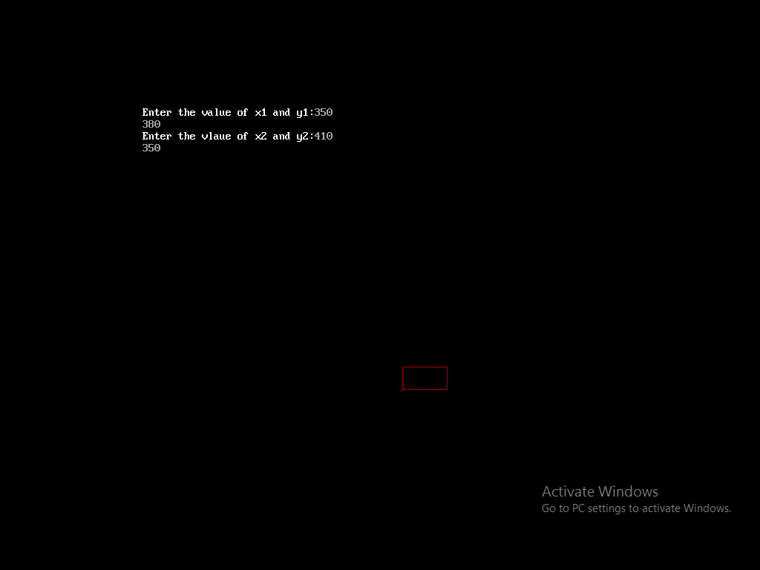

/*Write a program to Draw a Square*\

#include<graphics.h>
#include<conio.h>
#include<stdio.h>
int line1(int x1,int y1,int x2,int y2);
void main()
{
int x1,x2,y1,y2,length,dx,dy,x,y,k;
int gdriver=DETECT,gmode,errorcode;
initgraph(&gdriver,&gmode,"..\\bgi");
printf("Enter the value of x1 and y1:");
scanf("%d%d",&x1,&y1);
printf("Enter the vlaue of x2 and y2:");
scanf("%d%d",&x2,&y2);
line1(x1,y2,x2,y2);
line1(x2,y2,x2,y1);
line1(x1,y1,x2,y1);
line1(x1,y1,x1,y2);
getch();
closegraph();
}
int line1(int x1,int y1,int x2,int y2)
{
int length,dx,dy,x,y,k;
if(abs(x2-x1)>abs(y2-y1))
length=abs(x2-x1);
else
length=abs(y2-y1);
dx=(x2-x1)/length;
dy=(y2-y1)/length;
x=x1;
y=y1;
putpixel(x,y,RED);
for(k=1;k<=length;k++)
{

x=x+dx;
y=y+dy;
putpixel(x,y,RED);
delay(100);
}
}

Output:-
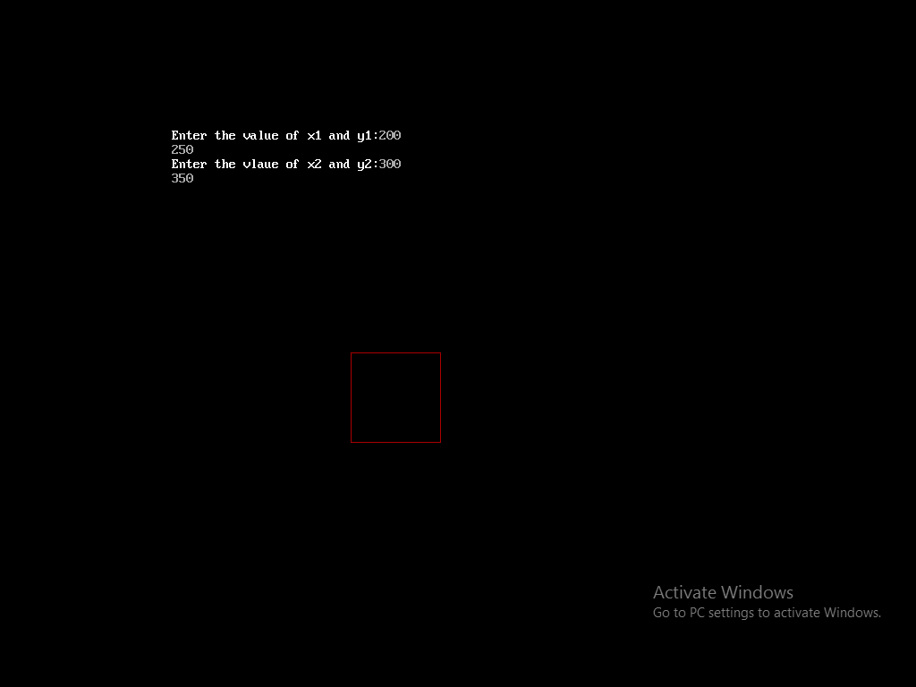

/*Write a program to Draw a Triangle*\

#include<graphics.h>
#include<conio.h>
#include<stdio.h>
#include<dos.h>
#include<math.h>
#include<stdlib.h>
dline(int,int,int,int);
void main()
{
int x1,y1,x2,y2,x3,y3;
int gdriver=DETECT,gmode,errorcode;
initgraph(&gdriver,&gmode,"..\\bgi");
printf("Enter the value of x1 and y1:");
scanf("%d%d",&x1,&y1);
printf("Enter the value of x2 and y2:");
scanf("%d%d",&x2,&y2);
printf("Enter the value of x3 and y3:");
scanf("%d%d",&x3,&y3);
dline(x1,y1,x2,y2);
dline(x1,y1,x3,y3);
dline(x2,y2,x3,y3);
getch();
closegraph();
}
dline(int x1,int y1,int x2,int y2)
{
int dx,dy,step,xinc,yinc,x,y,k;
dx=x2-x1;
dy=y2-y1;
if(abs(dx)>abs(dy))
step=abs(dx);
else
step=abs(dy);
xinc=dx/step;
yinc=dy/step;
x=x1;

y=y1;
putpixel(x,y,GREEN);
for(k=0;k<step;k++)
{
x=x+xinc;
y=y+yinc;
delay(10);
putpixel(x,y,GREEN);
}
}

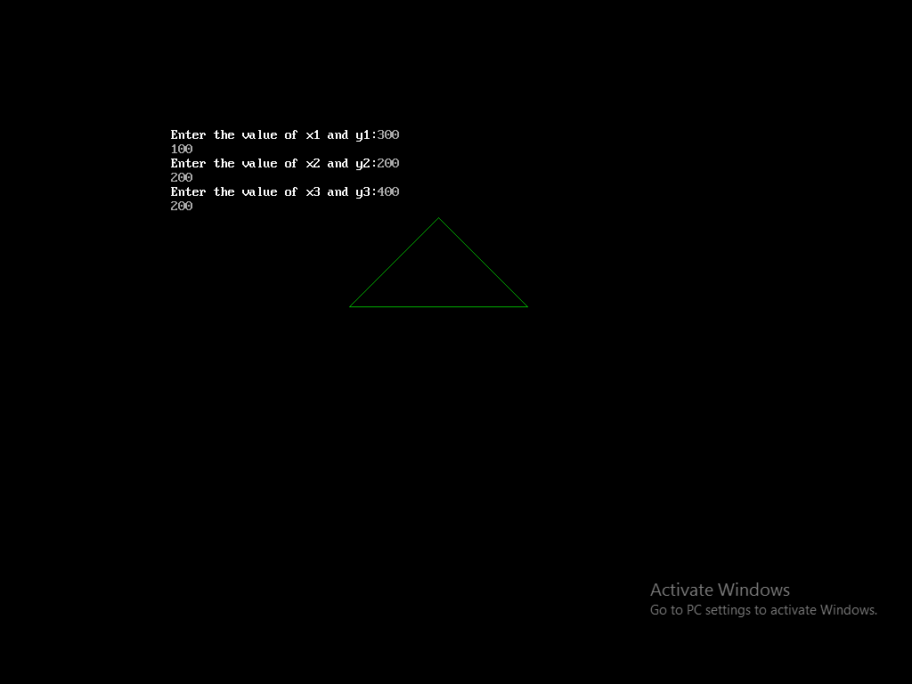
Output:-

/*Write a program to Draw a Circle Bheresham*\

#include<iostream.h>
#include<conio.h>
#include<graphics.h>
#include<math.h>
#include<stdlib.h>
#include<dos.h>
void circlepoint(int,int,int,int);
void cirmid(int,int,int);
void main()
{
int x,y,r;
int gdriver=DETECT,gmode,errorcode;
initgraph(&gdriver,&gmode,"..\\bgi");
cout<<"Enter the vlaue of x and y:";
cin>>x>>y;
cout<<"Enter the value of radius;";
cin>>r;
cirmid(x,y,r);
getch();
closegraph();
}
void cirmid(int xc,intyc,int r)
{
int x=0;
int y=r;
int p=1-r;
circlepoint(xc,yc,x,y);
while(x<y)
{
x++;
if(p<0)
p=p+2*x+1;
else
{
y--;

p=p+2*(x-y)+1;
}
circlepoint(xc,yc,x,y);
}
}
void circlepoint(int xc,intyc,intx,int y)
{
delay(10);
putpixel(xc+x,yc+y,RED);
putpixel(xc-x,yc+y,RED);
putpixel(xc+x,yc-y,RED);
putpixel(xc-x,yc-y,RED);
putpixel(xc+y,yc+x,RED);
putpixel(xc-y,yc+x,RED);
putpixel(xc+y,yc-x,RED);
putpixel(xc-y,yc-x,RED);
}

Output:-
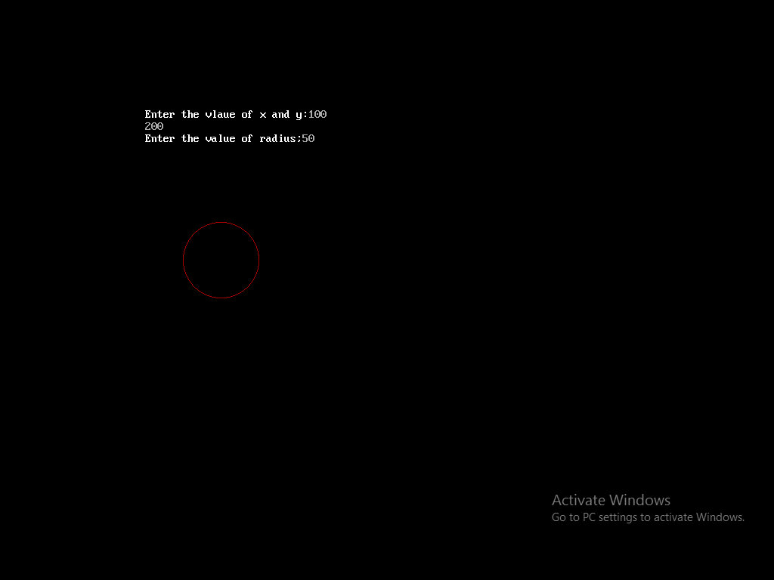

/*Write a program to Draw a line through Mid-Point Line Algorithm*\

#include<stdio.h>
#include<conio.h>
#include<graphics.h>
void main()
{
int dx,dy,x,y,c,ince,incne,xa,xb,ya,yb;
int gdriver=DETECT,gmode,errorcode;
initgraph(&gdriver,&gmode,"..\\bgi");
printf("Enter the vlaue of xa and ya:");
scanf("%d%d",&xa,&ya);
printf("Enter the value of xb and yb:");
scanf("%d%d",&xb,&yb);
dx=xb-xa;
dy=yb-ya;
c=2*(dy-dx);
ince=dy*2;
incne=(dy-dx)*2;
y=ya;
x=xa;
putpixel(x,y,2);
while(x<=xb);
{
if(c<=0)
{
c=c+incne;
x++;
}
else
{
c=c+incne;
x++;
y++;
}

putpixel(x,y,2);
}
getch();
closegraph();
}

Output:-
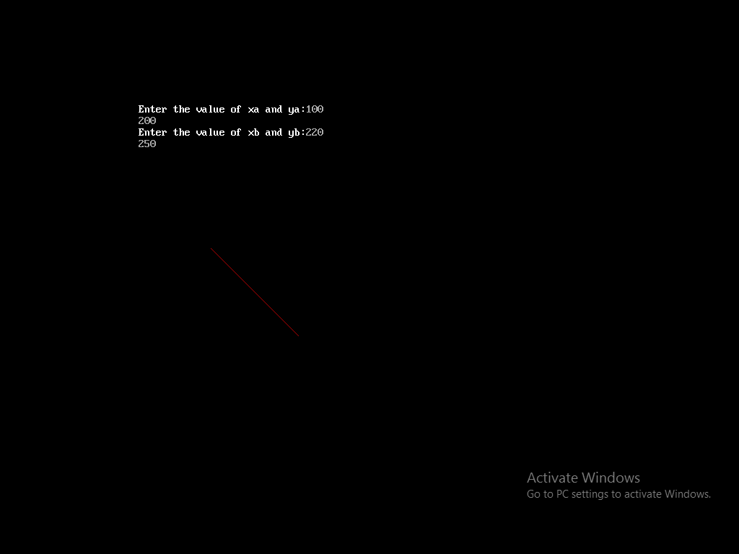

/*Write a program to Draw a 2D Translation*\

#include<stdio.h>
#include<conio.h>
#include<graphics.h>
int line1(int x1,int x2,int y1,int y2);
void main()
{
int x1,x2,y1,y2,l,dx,dy,x,y,k,tx,ty;
int gdriver=DETECT,gmode,errorcode;
initgraph(&gdriver,&gmode,"..\\bgi");
printf("Enter the vlaue of x1 and y1:");
scanf("%d%d",&x1,&y1);
printf("Enter the value of x2 and y2:");
scanf("%d%d",&x2,&y2);
line1(x1,y2,x2,y2);
line1(x2,y2,x2,y1);
line1(x1,y1,x2,y1);
line1(x1,y1,x2,y2);
printf("Enter the translation coordinates:");
scanf("%d%d",&tx,&ty);
line1(x1*tx,y2*ty,x2*tx,y2*ty);
line1(x2*tx,y2*ty,x2*tx,y1*ty);
line1(x1*tx,y1*ty,x2*tx,y1*ty);
line1(x1*tx,y1*ty,x1*tx,y2*ty);
getch();
closegraph();
}
int line1(int x1,int y1,int x2,int y2)
{
int l,dx,dy,x,y,k;
if(abs(x2-x1)>abs(y2-y1))
l=abs(x2-x1);
else
l=abs(y2-y1);
dx=(x2-x1)/l;
dy=(y2-y1)/l;
x=x1;
y=y1;
putpixel(x,y,2);
for(k=1;k<=l;k++)
{
x=x+dx;
y=y+dy;
putpixel(x,y,2);
delay(100);
}
}

Output:-
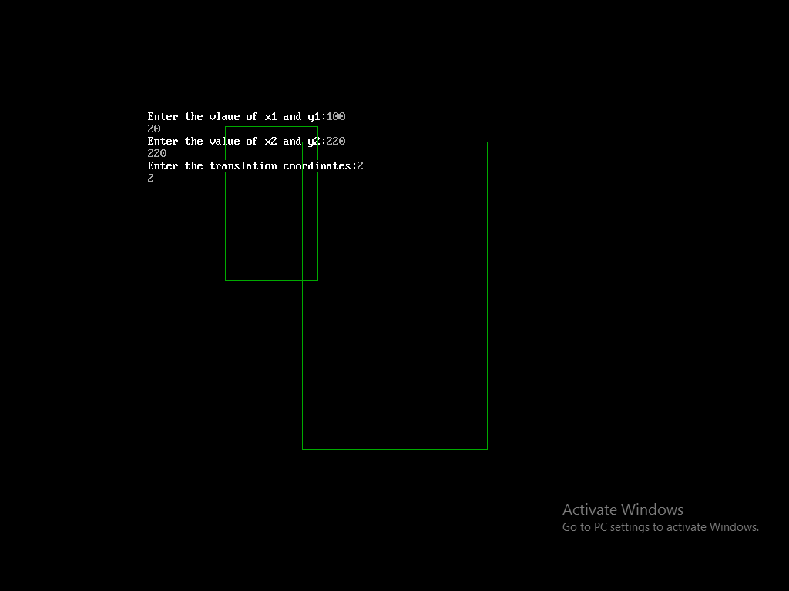

/*Write a program to Draw a 2D Scaling*\

#include<stdio.h>
#include<conio.h>
#include<graphics.h>
int line1(int x1,int x2,int y1,int y2);
void main()
{
int x1,x2,y1,y2,l,dx,dy,x,y,k,sx,sy;
int gdriver=DETECT,gmode,errorcode;
initgraph(&gdriver,&gmode,"..\\bgi");
printf("Enter the vlaue of x1 and y1:");
scanf("%d%d",&x1,&y1);
printf("Enter the value of x2 and y2:");
scanf("%d%d",&x2,&y2);
line1(x1,y2,x2,y2);
line1(x2,y2,x2,y1);
line1(x1,y1,x2,y1);
line1(x1,y1,x2,y2);
printf("Enter the scalling coordinates:");
scanf("%d%d",&sx,&sy);
line1(x1/sx,y2/sy,x2/sx,y2/sy);
line1(x2/sx,y2/sy,x2/sx,y1/sy);
line1(x1/sx,y1/sy,x2/sx,y1/sy);
line1(x1/sx,y1/sy,x1/sx,y2/sy);
getch();
closegraph();
}
int line1(int x1,int y1,int x2,int y2)
{
int l,dx,dy,x,y,k;
if(abs(x2-x1)>abs(y2-y1))
l=abs(x2-x1);
else
l=abs(y2-y1);
dx=(x2-x1)/l;

dy=(y2-y1)/l;
x=x1;
y=y1;
putpixel(x,y,2);
for(k=1;k<=l;k++)
{
x=x+dx;
y=y+dy;
putpixel(x,y,2);
delay(100);
}
}

Output:-
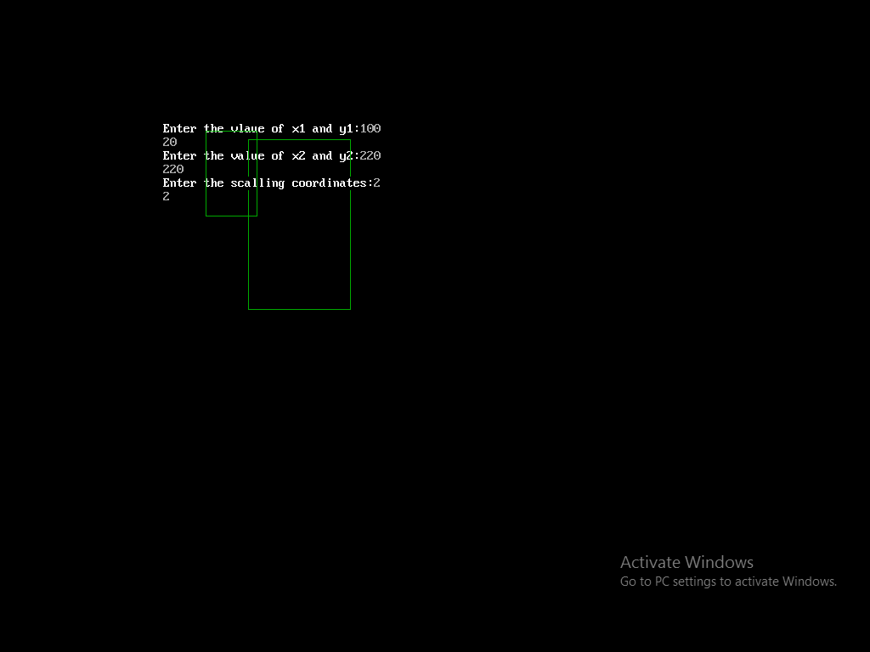

/* Write a program to draw Indian flag on screen*\

#include<graphics.h>
#include<conio.h>
void main()
{
int gdriver=DETECT,gmode,errorcode;
initgraph(&gdriver,&gmode,"..\\bgi");
setcolor(5);
line(20,50,20,180);
line(20,50,100,50);
line(20,70,100,70);
line(20,90,100,90);
line(20,110,100,110);
line(100,50,100,110);
circle(60,80,10);
line(52,80,68,80);
line(60,72,60,88);
setfillstyle(SOLID_FILL,22);
floodfill(21,51,5);
setfillstyle(SOLID_FILL,7);
floodfill(21,75,5);
setfillstyle(SOLID_FILL,2);
floodfill(21,95,5);
setfillstyle(SOLID_FILL,7);
floodfill(81,75,5);
setfillstyle(SOLID_FILL,7);
floodfill(61,81,5);
getch();
closegraph();
}

Output:-

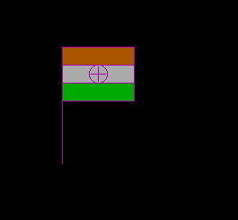

/* Write a program to Make a Hut*\

#include<graphics.h>
#include<conio.h>
void main()
{
int gdriver=DETECT,gmode,errorcode;
initgraph(&gdriver,&gmode,"..\\bgi");
setcolor(6);
rectangle(50,180,150,300);
rectangle(150,180,320,300);
rectangle(80,250,120,300);
line(100,100,150,180);
line(100,100,270,100);
line(270,100,320,180);
line(100,100,50,180);
getch();
closegraph();
}

Output:-

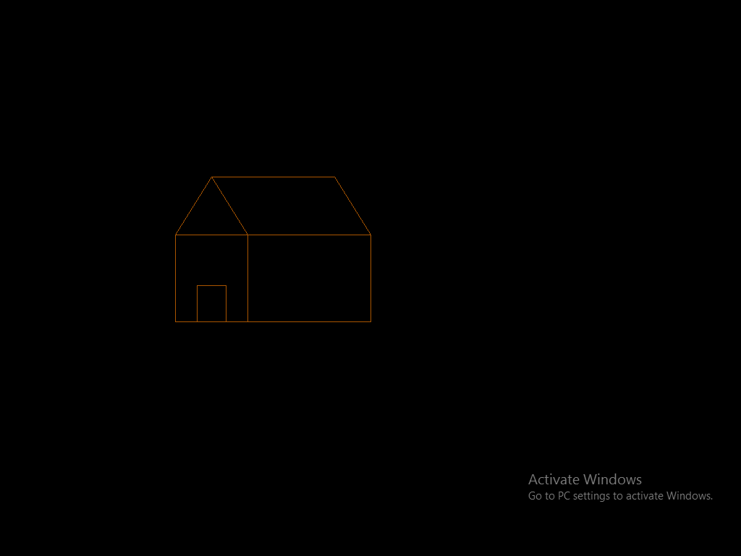
/*Write a program to Draw a Kite*\

#include<conio.h>
#include<graphics.h>
void main()
{
int gdriver=DETECT,gmode,errorcode;
initgraph(&gdriver,&gmode,"..\\bgi");
line(100,100,50,180);
line(100,100,150,180);
line(50,180,100,250);
line(150,180,100,250);
line(100,100,100,250);
line(50,180,150,180);
line(100,250,70,300);
line(100,250,130,300);
line(70,300,130,300);
line(100,300,120,320);
line(120,320,80,340);
line(80,340,120,360);
line(120,360,80,380);
setcolor(4);
getch();
closegraph();
}
Output:-
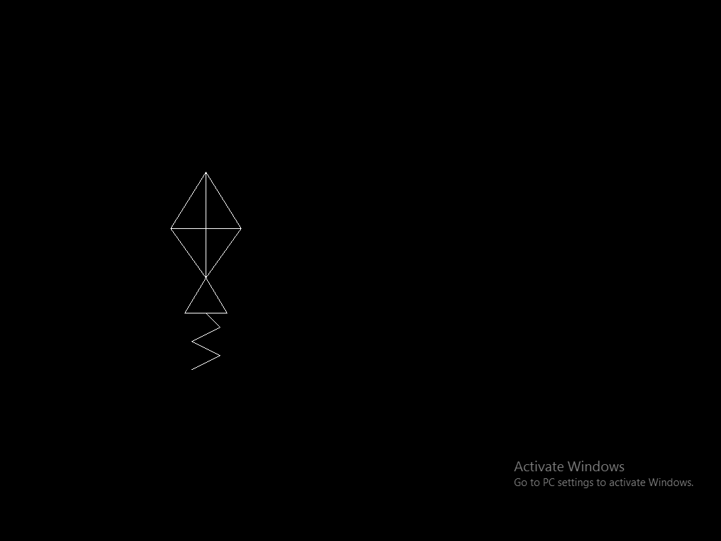

/*Write a program to Draw a Fish*\

#include<graphics.h>
#include<conio.h>
void main()
{
int gdriver=DETECT,gmode,errorcode;
initgraph(&gdriver,&gmode,"..\\bgi");
ellipse(200,200,0,360,50,30);
line(250,200,280,170);
line(280,170,280,230);
line(280,230,250,200);
circle(160,190,3);
getch();
closegraph();
}

Output:-

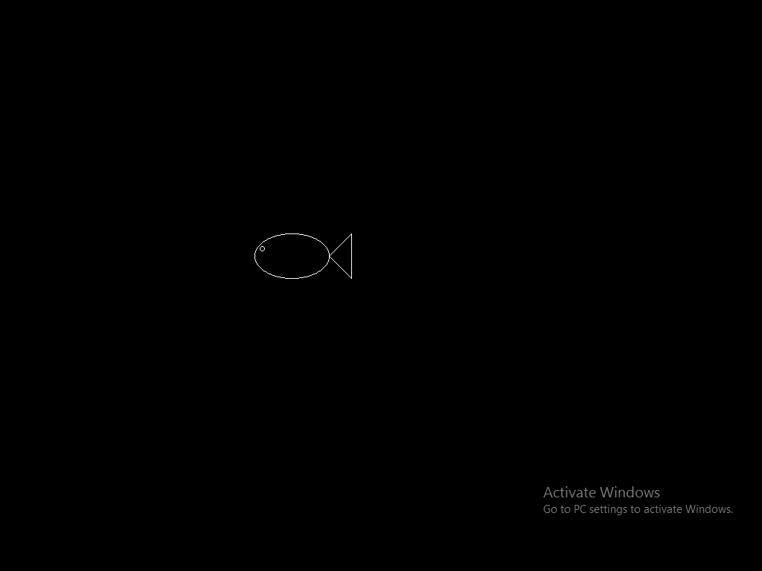

/*Write a program to Change Background Colour Through pre-defined Function*\

#include<graphics.h>
#include<conio.h>
void main()
{
int gdriver=DETECT,gmode,errorcode;
initgraph(&gdriver,&gmode,"..\\bgi");
setbkcolor(GREEN);
getch();
closegraph();
}

Output:-

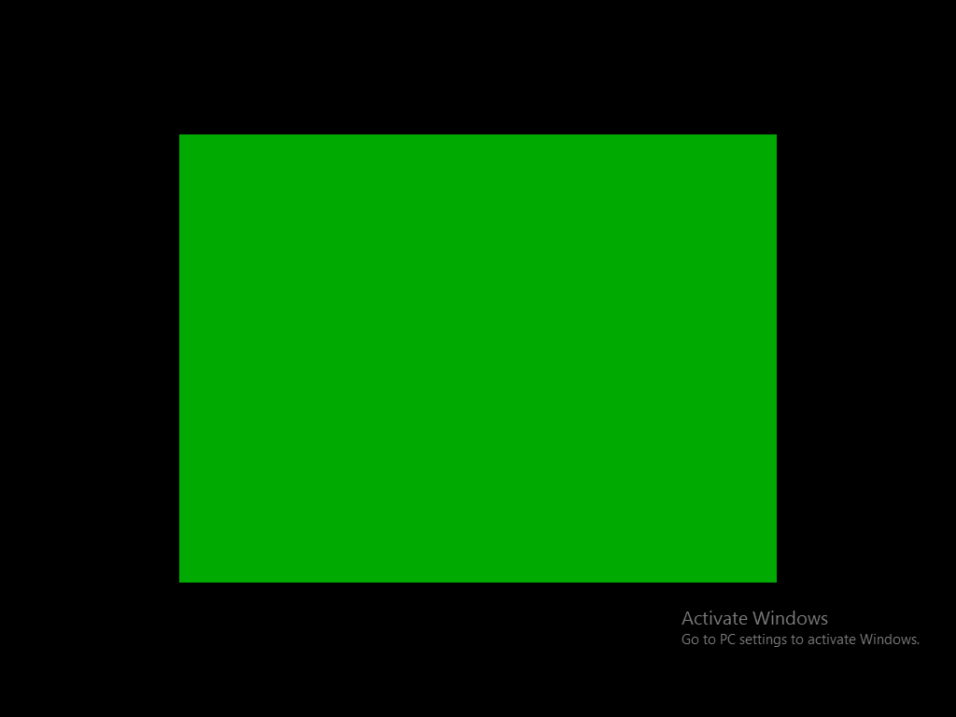

/*Write a program to Filling Style Change Function*\

#include<graphics.h>
#include<conio.h>
void main()
{
int gdriver=DETECT,gmode,errorcode;
initgraph(&gdriver,&gmode,"..\\bgi");
setfillstyle(XHATCH_FILL,RED);
circle(100,100,50);
floodfill(100,100,WHITE);
getch();
closegraph();
}

Output:-

